 | SAMANDAR MIRZAEV  Mobile: +971553943223  Email: samandarmirzayev@gmail.com  GitHub: https://github.com/sammirzaev  LinkedIn: https://www.linkedin.com/in/samandar-mirzaev-802181b3/  Full Stack Web Developer/ IT Specialist
Personal summary: | Top performing IT professional and Full Stack Web Developer with overall 5 years’ successful experience in Information Technology and Full Stack Web Developer fields. Proficient in hardware and software maintenance. Solid track record of providing the timely positive response to requests regarding computer-related assistance. Strong understanding of the organizational confidentiality policies associated with IT specialist position.
Language skills: | English (fluent), Russian (fluent), Turkish (basic)
Education: | Tashkent State of Technical University  Bachelor degree of Automation and Control 2006 y.- 2010 y. (GPA: 89%)  Tashkent State of Technical University  Master degree in Process of technology and manufacturing automation  2010 y.- 2012 y. (GPA: 90%)
Projects: | Hospitality Suppliers : www.mirsupplies.com  Front-End : jQuery, JavaScript, PHP, HTML5, CSS3, Bootstrap framework  Back-End: JavaScript, NPM Packages, GruntJs, PHP7, MDBootstrap  Caesars Bluewaters Island Inventory Management System  CodeIgniter framework, jQuery, AJAX, JavaScript, HTML5, CSS3, PHP OOP, Bootstrap Framework  JRG(Jumeirah Restaurant Group): Fast and Slow Moving Items  Excel, VBA, Macros  Caesars Bluewaters Dubai: Caesars Voucher Application  JavaScript, jQuery, HTML5, CSS3, Bootstrap framework, Laravel, MySQL  Canadian Tailoring Company: www.walinsgroup.com  JavaScript, jQuery, HTML5, CSS3, Bootstrap framework  Jumeirah IT Store Inventory Management System web-based application  CodeIgniter framework, jQuery, AJAX, JavaScript, HTML5, CSS3, PHP OOP, Bootstrap Framework.  JRG(Jumeirah Restaurant Group): www.festivefunderland.com  jQuery, JavaScript, PHP, HTML5, CSS3, Bootstrap framework
Certify: | Cross training in Burj Al Arab, Information and Technologies department  Cross training in Jumeirah Group LLC, Sales and Marketing department
Skills: | - PHP 7 / OOP PHP / Laravel PHP/ Codeigniter PHP / Node.JS / JavaScript/ HTML5/ CSS3/ MongoDB-NoSQL / MySQL / SQL/ AJAX / JQuery / ExpressJS / Bootstrap4/ Angular  - Photoshop/ Illustrator / InDesign/ UleadVideoStudio/Pinacle/Photodex  - Networking / OPERA PMS /WindowsServer 2012/2016 R2/ M-COM Configuration/ Vicas Configuration / Office 365 / SUN System Configuration / Cisco PABX System  - Problem solving / Customer service skills / Troubleshooting
  Career history: | Caesars Bluewaters Resort (Pre-Opening) Dubai, UAE  IT Specialist (Cluster) Aug 2018 - Present  - Inspecting, testing, and diagnosing computer equipment and systems. Troubleshooting Network and PC related issues.  - Ensures that computer and network operations are monitored at the property, data backup/recovery functions are performed on scheduled basis as per IT internal audit policies. Keeps current all systems documentation, training manuals, and operational procedures.  - Installation, Configuration and Maintenance of the following Hospitality based applications: OPERA v5.5, SUN Accounting System, KnowCross, Vicas, Adaco, Tiger Call Accounting, OASYS, Book4Time, VingCard  - Following all company policies and procedures to protect company assets.  - Supporting the activities of the IT Manager & IT Director in order to ensure the smooth running of the IT Department and Systems of the hotel  - Responsible Developing New Applications as per requirements of company (Using Latest Programming Technology)  - Reporting to the IT manager all technical issues related to IT infrastructure  - Liaises with appropriate support organizations relating to system problems
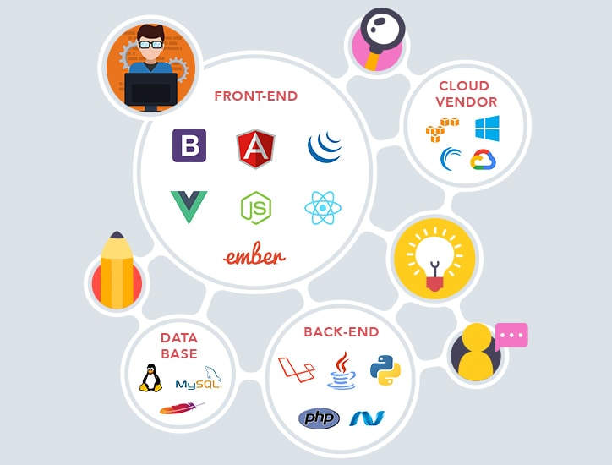 | Remote Work and Freelancer Dubai,UAE  Full Stack Web Developer and SEO Professional March 2015 – Present  Responsible for create new web based applications as per customer requirements, Software Testing Life Cycle (STLC Manual) of the application, then deployment and SEO (Searching Engine Optimization) such a google seo, bing seo, google ads etc.
 | ERIELL Corporation L.L.C Moscow. Russia  Artificial Intelligence/ Top Driver Specialist J a n 2 0 1 3 - M a r c h 2 0 1 5  Responsible for Automatization and Control system machines of ZJ 70LDB (Rig Machine), ZJ 70LDBS (Rig Machine), ZJ40LDB hybrid device (Rig Machine) and ZJ 50LDB mobile devices (Rig Machine). Electronic systems, step7 industrial software and fix and error handling on system and hardware top driver electronic parts and systems, reassembling and assembling rig device, supply with electric and electronic powers, control and create system with simulators by system Honeywell, control and repair. Used Step7 software for AI. Automating |Machines by using step7 software (Top Driver device) connecting with Honeywell relays, re-writing codes in the micro-chips, making machine work perfectly remotely for smooth operation.
 | UzbekOil&Gas Holding Uzbekistan. Tashkent  IT Execetive/Jr. Full Stack Web Developer F e b 2010 - Dec 2012  Supporting IT Related Issues, Troubleshooting and Developing New Required Systems, Managing company website http://www.ung.uz/
Completed Projects: | - mirsupplies.com application promoting company products, front-end part used Bootstrap4, HTML5,CSS3, JavaScript. Back-end server side used php7, php oop, mysql.  - walinsgroup.com application only static and website promoting items of company  - imecmep.com constructor company website made with wordpress, I have done for this website SEO ( google search engine optimization and google ads)
Jumeirah Group Web Based Applications | - festivefunderland.com restaurant booking system : application used for promoting outlets in Jumeriah restaurant group and booking. Front-end made with HTML5, CSS3, Bootstrap4, JavaScript, jQuery. Back-End server using with php7, php oop, mysql  - IT Inventory Management System: application will work internal, basically application for using maintaining IT devices, users, hardware and software. Application used codeigniter php framework. Front-End used: HTML5, CSS3, Bootstrap4, MaterialDesign, Back-End server side user php-codeigniter 3, mysql, ajax
Caesars Bluewaters Web Based Applications | - Caesars IT Inventory Management System: This application web based and will work only internal. System will manage inventory of IT products, active, not active users, phones, phone numbers, hardware and software. Application will save a lot of time and save a lot of paper wastage. System has type of user panels, it will search registered items by type, by location and it is very easy find out items and manage. Application developed with codeigniter php framework, front-end used HTML5, CSS3 , Bootstrap4, Boostrap MDB. Bac-end server side used with codeigniter php, ajax, mysql.  - Caesars Vouchers System: Application web based system and will work only internal. Caesars Voucher system will create voucher and will redeem voucher. Once redeem voucher system will send email to the guest about redeemed voucher then for confirmation system able to create invoice and can print as well, there smart features developed once user created new voucher that voucher will appear under user name then it will give notification, user once click redeem voucher, it will not be revert back because system will send email to the guest. This application created because of there is company used different voucher system, but there guest can use that voucher with friends, and colleagues not able to find by paper and it was very difficult find out with Caesars voucher system you will search voucher code and user easy to confirm that voucher used or not. Application developed with Laravel 5.8 framework. Front-End used HTML5, CSS3, Bootstrap4, MaterialDesign, JavaScript, jQuery, Back-end server side used Laravel framework, ajax, jquery, mysql, homestead, Ubuntu 18.04.3.  - Caesars IT Checklist system: Application web based, system will work only internal, Application will make easy operation and will remind IT Department daily checklists need to be done, checklist will remind what need to check software and hardware daily , monthly and yearly and it will send email to group email. Project still ongoing, Checklist system developing with Laravel 5.8, used for Front-end Boostrap4, Boostrap MDB, Material Design, HTML5, CSS3, JavaScript, jQuery. Back-end server side using Laravel 5.8 faremwork, mysql, ajax, mysql server workbench, apache server

